Falcon Fitness Center

Home

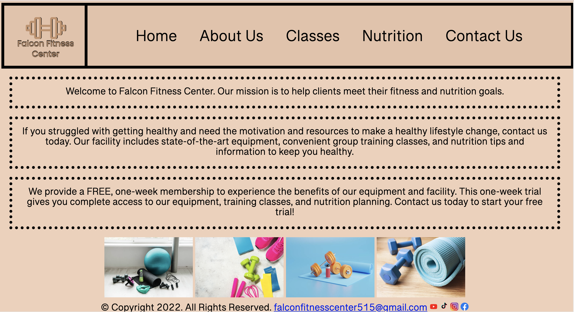

<DOCTYPE html>

<html lang="en">

<head>

<title> Falcon Fitness Center </title>

<meta charset="utf-8">

<link href="css/externalstylesheetFFC.css" rel="stylesheet">

<link href="https://fonts.googleapis.com/css2?family=Raleway:wght@300&family=Roboto&display=swap" rel="stylesheet">

</head>

<style>

nav{

width:100%;

background-color:#E6C3A9;

height:150px;

border:solid 7px black;

}

nav ol{

text-align:center;

top:100px;

}

nav ol li{

list-style:none;

display:inline-block;

justify-content: center;

margin-top:10px;

}

nav ol li a{

display:block;

text-decoration:none;

color:black;

font-size:40px;

font-weight:500;

padding:25px;

}

nav ol li a:hover{

background-color:#f0d0b9;

transition: all ease 1.5s;

}

.img{

float:left;

border:7px solid black;

}

</style>

<body>

<header>

<div class="img">

<a href="index.html"><img src="images/FFCLogoPrimary.png" alt="Falcon Fitness Center Logo" height="150" width="200"></a> <br>

</div>

<nav>

<ol>

<li><a href="index.html">Home</a></li>

<li><a href="about.html">About Us</a></li>

<li><a href="classes.html">Classes</a></li>

<li><a href="nutrition.html">Nutrition</a></li>

<li><a href="contact.html">Contact Us</a></li>

</ol>

</nav>

</header>

<main>

<p> Welcome to Falcon Fitness Center. Our mission is to help clients meet their fitness and nutrition goals. </p>

<p> If you struggled with getting healthy and need the motivation and resources to make a healthy lifestyle change, contact us today. Our facility includes state-of-the-art equipment, convenient group training classes, and nutrition tips and information to keep you healthy. </p>

<p> We provide a FREE, one-week membership to experience the benefits of our equipment and facility. This one-week trial gives you complete access to our equipment, training classes, and nutrition planning. Contact us today to start your free trial! </p>

<img src="images/EquipmentNoPeople1.jpeg" alt="Image of Dumbell" height="150" width="220"> <img src="images/EquipmentNoPeople2.jpeg" alt="Image of Equipment" height="150" width="220"> <img src="images/EquipmentNoPeople3.jpeg" alt="Image of Equipment" height="150" width="220"> <img src="images/EquipmentNoPeople4.jpeg" alt="Image of Equipment" height="150" width="220">

<footer>

<div class="center">

&copy; Copyright 2022. All Rights Reserved.

<a href="mailto:falconfitnesscenter515@gmail.com">

falconfitnesscenter515@gmail.com</a>

<a href="https://www.youtube.com/"><img src="images/youtube.png" alt="Youtube Logo" height="20" width="20"></a>

<a href="https://www.tiktok.com/"><img src="images/tiktok.png" alt="TikTok Logo" height="25" width="20"></a>

<a href="https://www.instagram.com/"><img src="images/instagram.png" alt="instagram Logo" height="20" width="20"></a>

<a href="https://www.facebook.com/"><img src="images/facebook.png" alt="FaceBook Logo" height="20" width="20"></a>

</footer>

</main>

</body>

</html>

About Us

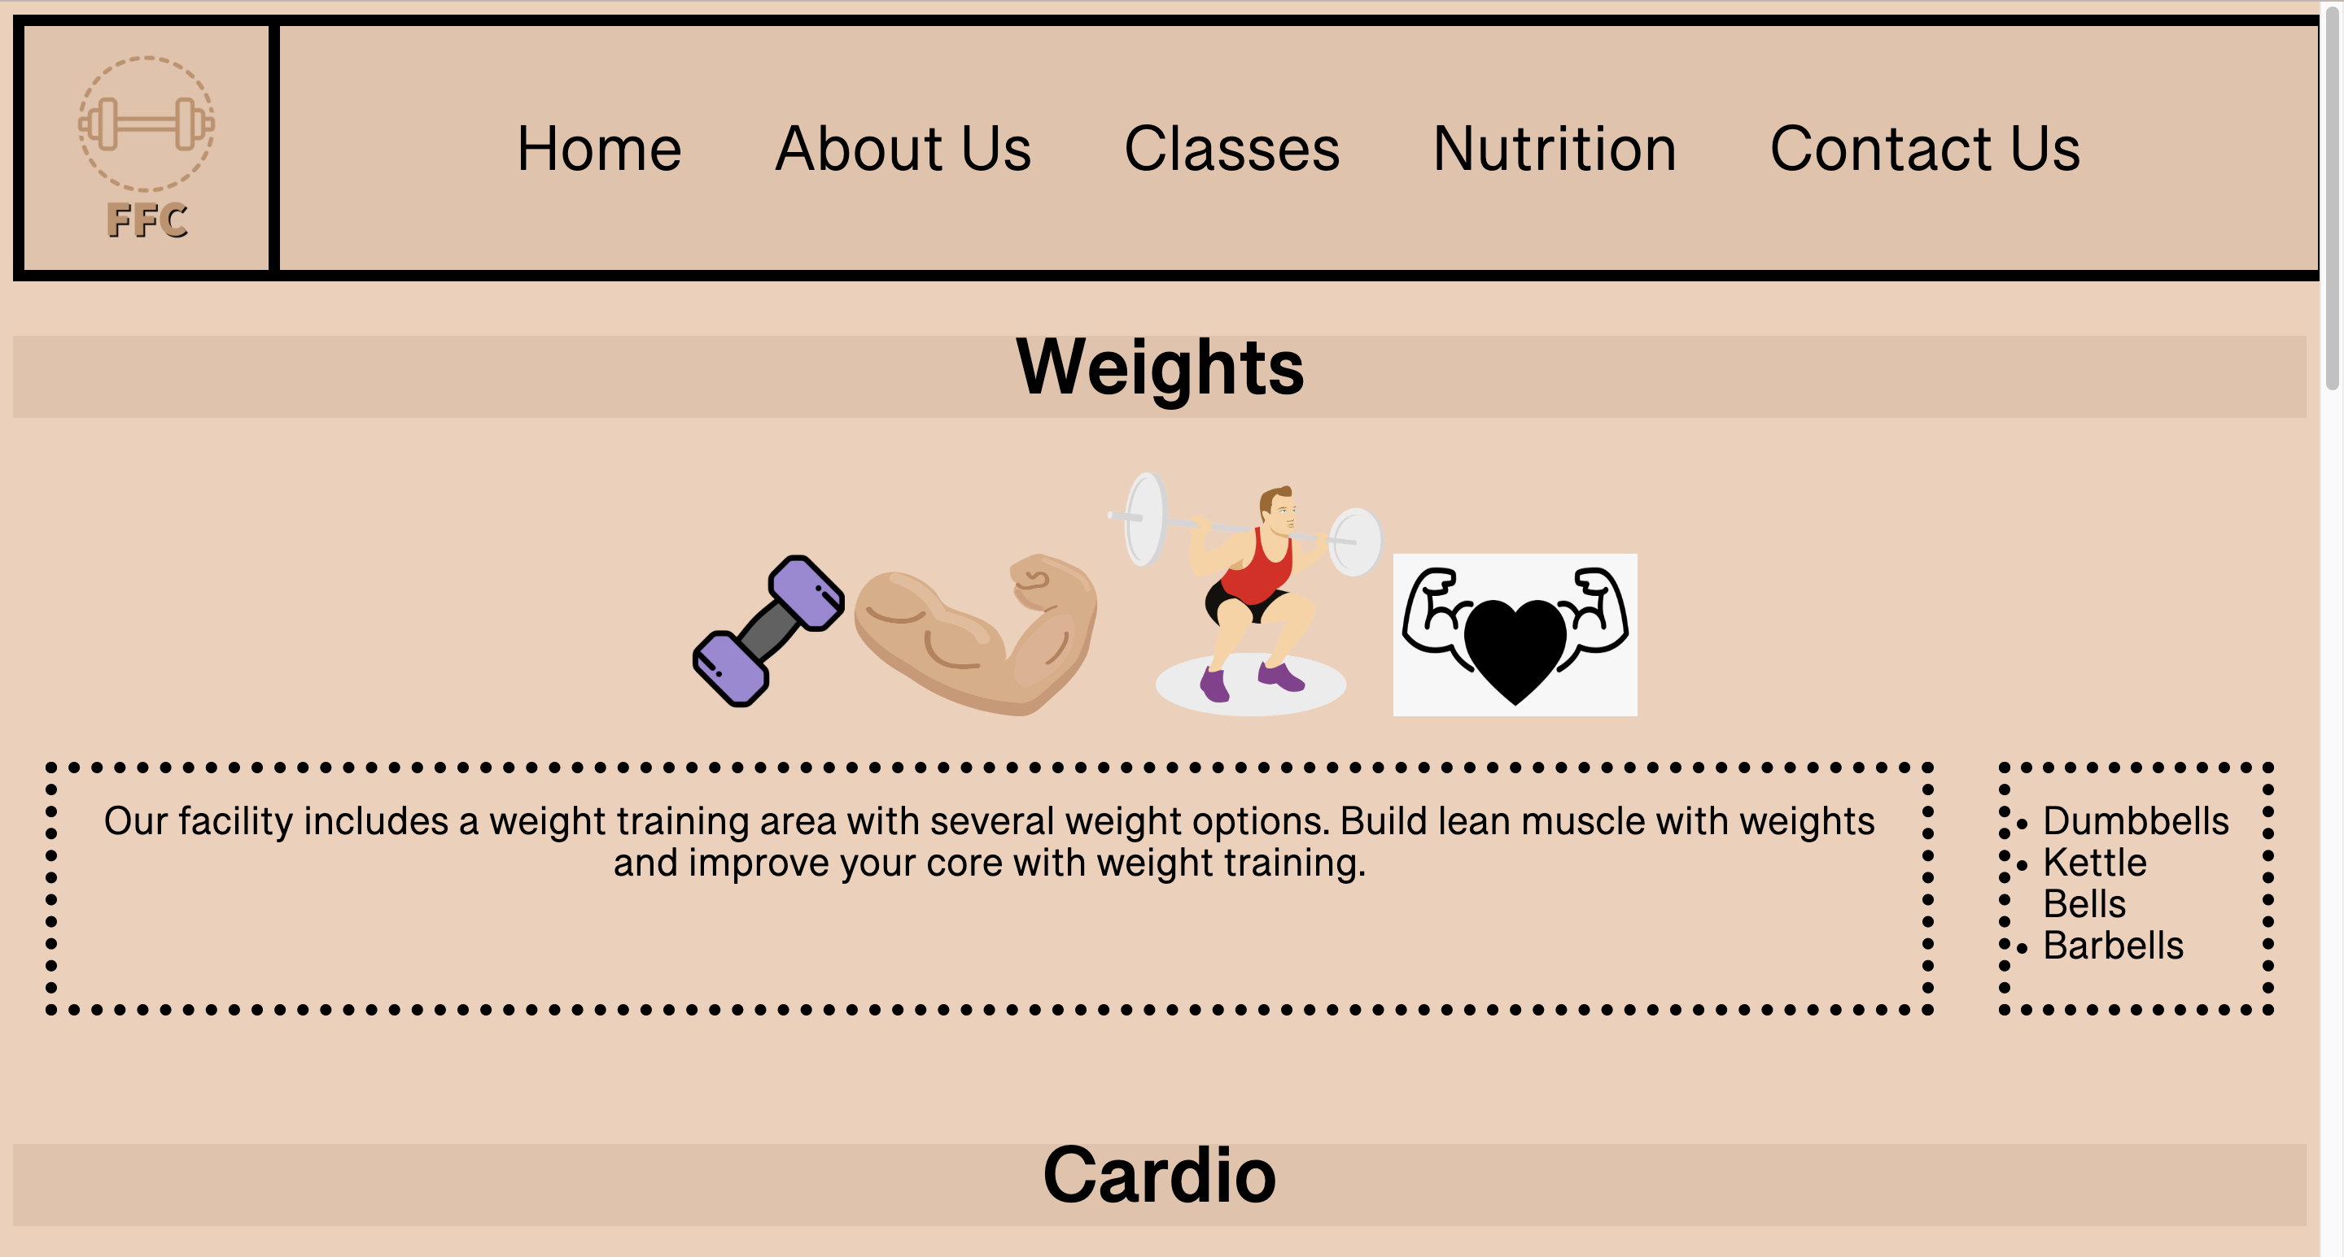

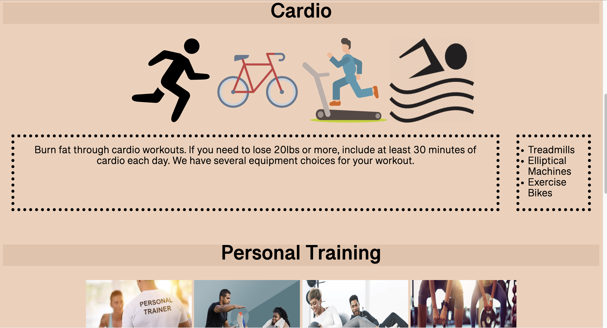

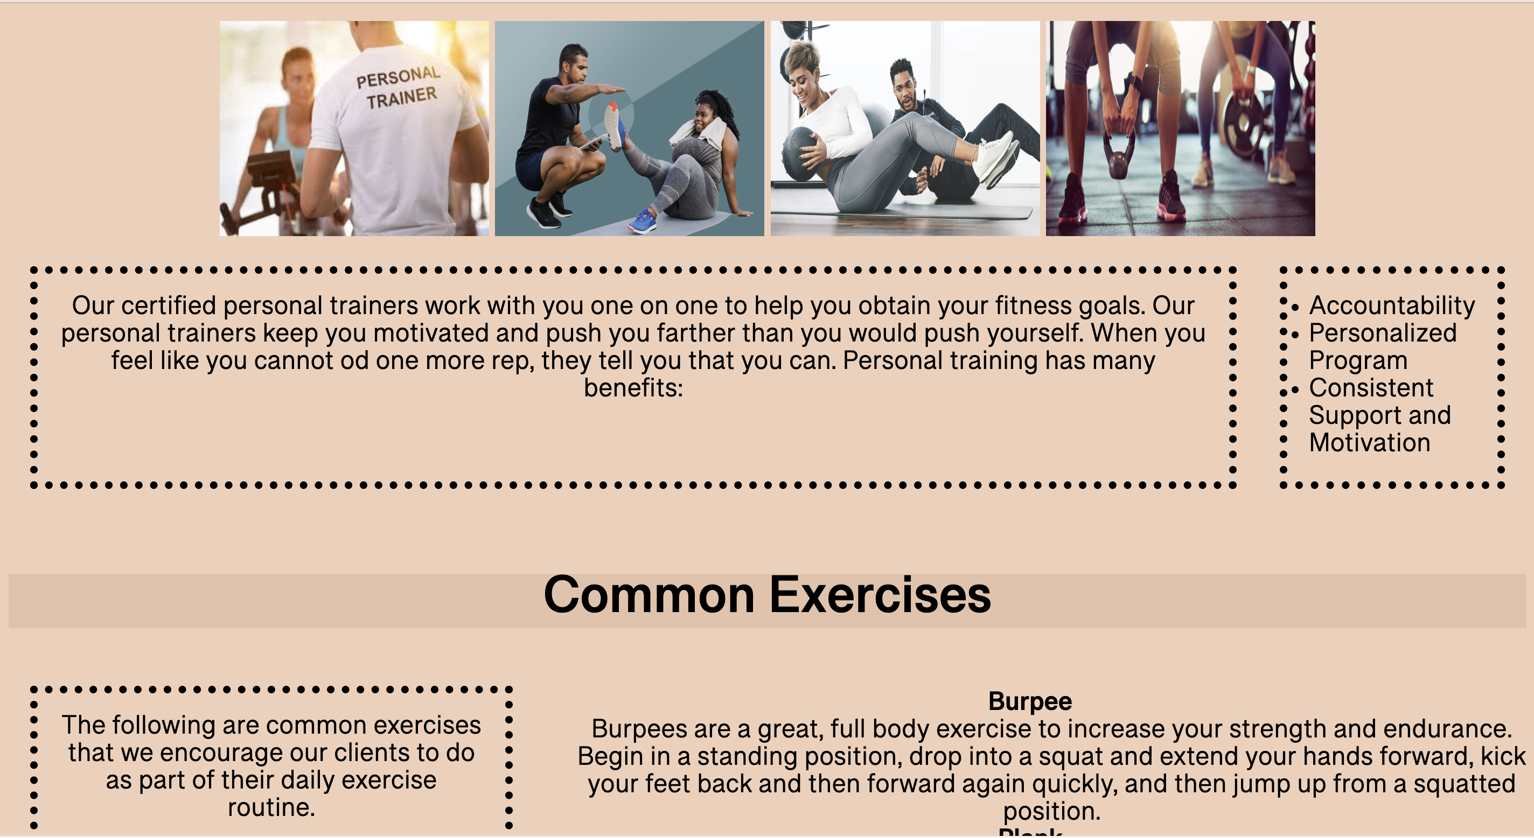

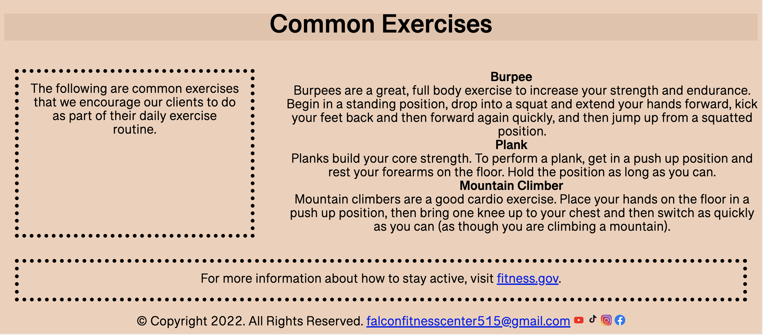

<DOCTYPE html>

<html lang="en">

<head>

<title> Falcon Fitness Center </title>

<meta charset="utf-8">

<link href="css/externalstylesheetFFC.css" rel="stylesheet">

<link href="https://fonts.googleapis.com/css2?family=Roboto&display=swap" rel="stylesheet">

</head>

<style>

nav{

width:100%;

background-color:#E6C3A9;

height:150px;

border:solid 7px black;

}

nav ol{

text-align:center;

top:100px;

}

nav ol li{

list-style:none;

display:inline-block;

justify-content: center;

margin-top:10px;

}

nav ol li a{

display:block;

text-decoration:none;

color:black;

font-size:40px;

font-weight:500;

padding:25px;

}

nav ol li a:hover{

background-color:#f0d0b9;

transition: all ease 1.5s;

}

.img{

float:left;

border:7px black solid;

}

.container5{

height:200px;

width:200px;

float:left;

}

.container6{

height:200px;

width:100%;

}

</style>

<body>

<header>

<div class="img">

<a href="index.html"><img src="images/FFCLogoSecondary.png" alt="Falcon Fitness Center Logo" height="150px" width="150px"></a> <br>

</div>

<nav>

<ol>

<li><a href="index.html">Home</a></li>

<li><a href="about.html">About Us</a></li>

<li><a href="classes.html">Classes</a></li>

<li><a href="nutrition.html">Nutrition</a></li>

<li><a href="contact.html">Contact Us</a></li>

</ol>

</nav>

</header>

<main>

<h1> Weights</h1>

<div class="container1">

<img class="equip" src="images/Weights1.png" alt="Picture of Weights" height="100" width="100">

<img src="images/muscles.png" alt="Picture of Muscles" height="100" width="150">

<img class="equip" src="images/Weightlifter.png" alt="Picture of Picking Up Weights" height="150" width="170">

<img class="equip" src="images/heart.png" alt="Picture of Heart and Weights" height="100" width="150">

</div>

<div class="container2">

<p> Our facility includes a weight training area with several weight options. Build lean muscle with weights and improve your core with weight training. </p>

<ul>

<li>Dumbbells</li>

<li>Kettle Bells</li>

<li>Barbells</li>

</ul>

</div><br>

<h1> Cardio </h1>

<div class="container1">

<img class="equip" src="images/Cardio1.png" alt="Running" height="200" width="200">

<img class="equip" src="images/Cardio2.png" alt="Biking" height="200" width="200">

<img class="equip" src="images/Cardio3.png" alt="Running on Treadmill" height="200" width="200">

<img class="equip" src="images/Cardio4.png" alt="Swimming" height="200" width="200">

<div class="container2">

<p>Burn fat through cardio workouts. If you need to lose 20lbs or more, include at least 30 minutes of cardio each day. We have several equipment choices for your workout. </p>

<ul>

<li>Treadmills</li>

<li>Elliptical Machines</li>

<li>Exercise Bikes</li>

</ul>

</div><br>

<h1>Personal Training</h1>

<div class="container1">

<img class="equip" src="images/personaltrainer1.jpeg" alt="Picture of Trainer" height="200" width="250">

<img class="equip" src="images/personaltrainer2.jpeg" alt="Picture of Trainer" height="200" width="250">

<img class="equip" src="images/personaltrainer3.jpeg" alt="Picture of Trainer" height="200" width="250">

<img class="equip" src="images/personaltrainer4.jpeg" alt="Picture of Trainer" height="200" width="250">

<div class="container2">

<p> Our certified personal trainers work with you one on one to help you obtain your fitness goals. Our personal trainers keep you motivated and push you farther than you would push yourself. When you feel like you cannot od one more rep, they tell you that you can. Personal training has many benefits: </p>

<ul>

<li>Accountability</li>

<li>Personalized Program</li>

<li>Consistent Support and Motivation</li>

</ul>

</div><br>

<h1> Common Exercises</h1>

<div class="container2">

<p> The following are common exercises that we encourage our clients to do as part of their daily exercise routine.</p>

<dl>

<dt><b>Burpee</b></dt>

<dd>Burpees are a great, full body exercise to increase your strength and endurance. Begin in a standing position, drop into a squat and extend your hands forward, kick your feet back and then forward again quickly, and then jump up from a squatted position.

<br></dd>

<dt><b>Plank</b></dt>

<dd>Planks build your core strength. To perform a plank, get in a push up position and rest your forearms on the floor. Hold the position as long as you can.

<br></dd>

<dt><b>Mountain Climber</b></dt>

<dd>Mountain climbers are a good cardio exercise. Place your hands on the floor in a push up position, then bring one knee up to your chest and then switch as quickly as you can (as though you are climbing a mountain).

<br></dd>

</dl>

</div>

<p>For more information about how to stay active, visit <a href="http://www.fitness.gov/be-active/ways-to-be-active/">fitness.gov</a>.</p>

</main>

<footer>

<div class="center">

&copy; Copyright 2022. All Rights Reserved.

<a href="mailto:falconfitnesscenter515@gmail.com">

falconfitnesscenter515@gmail.com</a>

<a href="https://www.youtube.com/"><img src="images/youtube.png" alt="Youtube Logo" height="20" width="20"></a>

<a href="https://www.tiktok.com/"><img src="images/tiktok.png" alt="TikTok Logo" height="25" width="20"></a>

<a href="https://www.instagram.com/"><img src="images/instagram.png" alt="instagram Logo" height="20" width="20"></a>

<a href="https://www.facebook.com/"><img src="images/facebook.png" alt="FaceBook Logo" height="20" width="20"></a>

</footer>

</div>

</body>

</html>

Classes

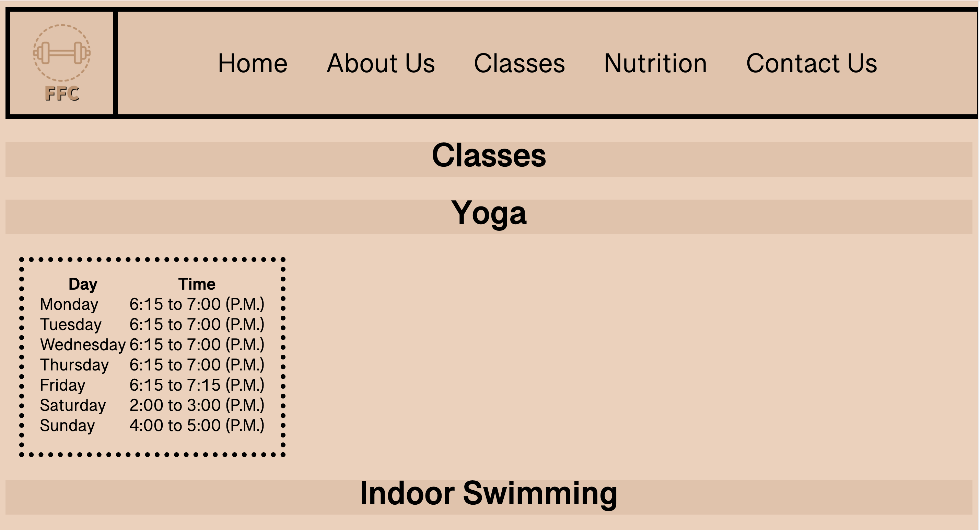

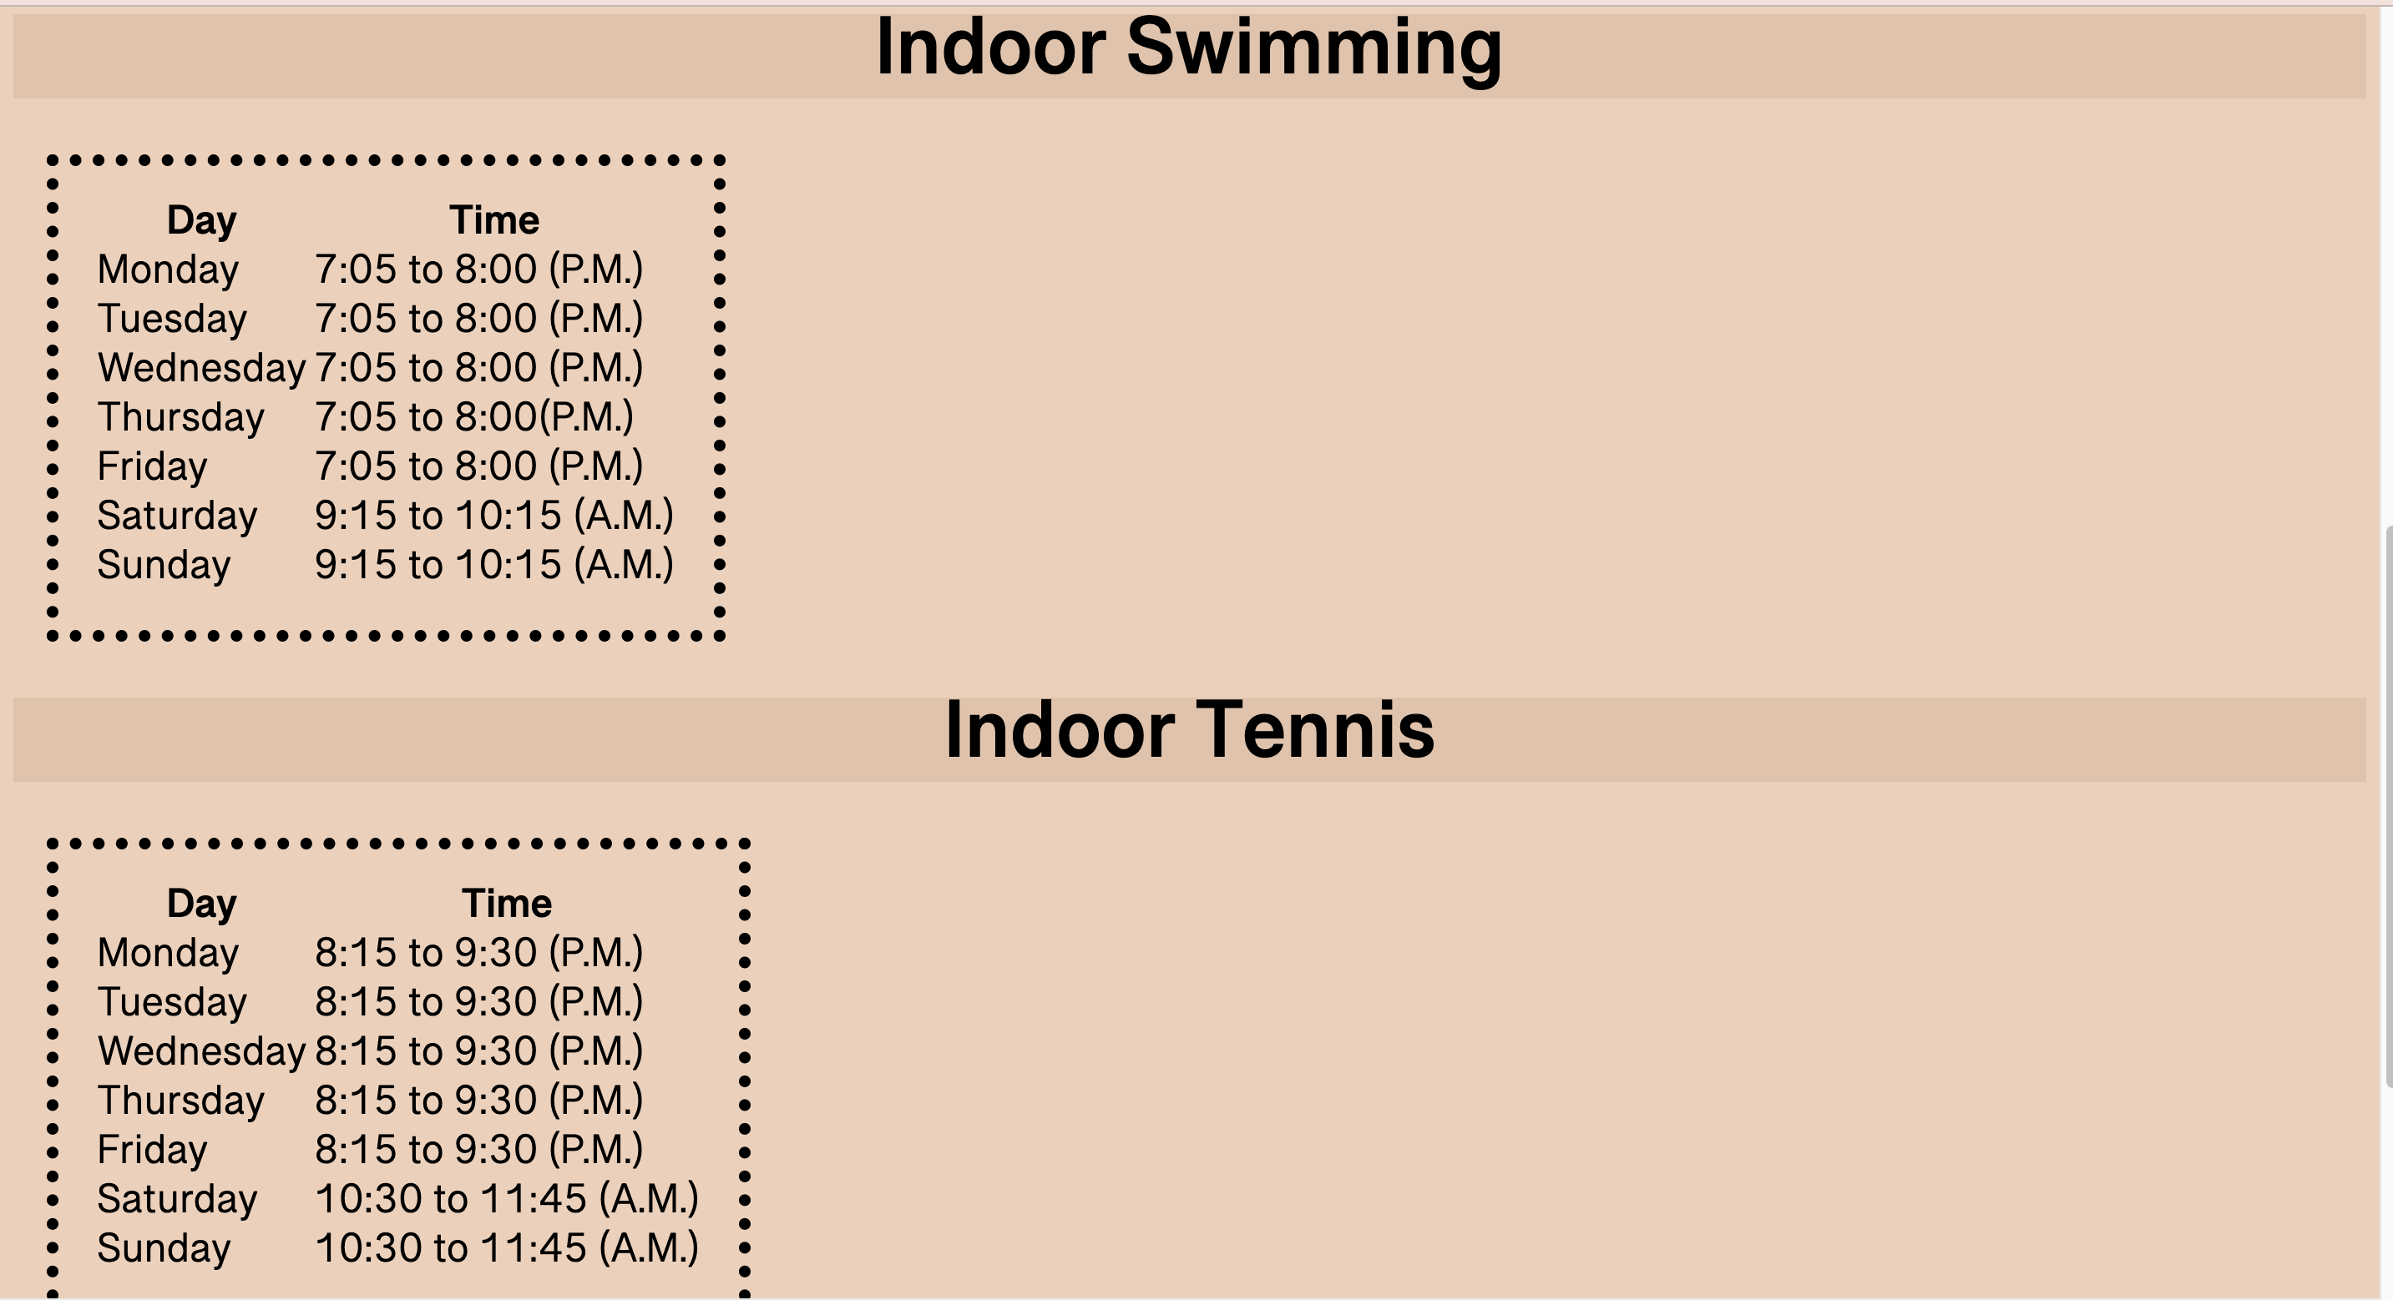

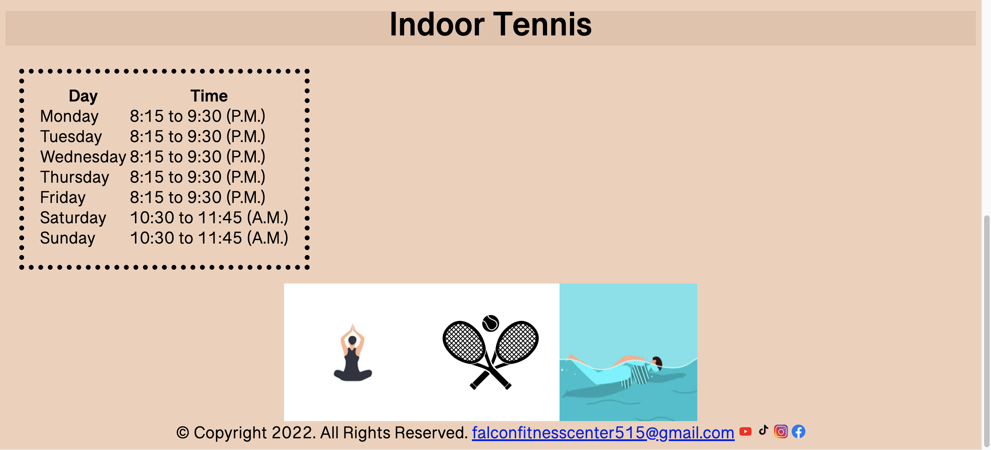

<DOCTYPE html>

<html lang="en">

<head>

<title> Falcon Fitness Center </title>

<meta charset="utf-8">

<link href="css/externalstylesheetFFC.css" rel="stylesheet">

<link href="https://fonts.googleapis.com/css2?family=Roboto&display=swap" rel="stylesheet">

</head>

<style>

nav{

width:100%;

background-color:#E6C3A9;

height:150px;

border:solid 7px black;

}

nav ol{

text-align:center;

top:100px;

}

nav ol li{

list-style:none;

display:inline-block;

justify-content: center;

margin-top:10px;

}

nav ol li a{

display:block;

text-decoration:none;

color:black;

font-size:40px;

font-weight:500;

padding:25px;

}

nav ol li a:hover{

background-color:#f0d0b9;

transition: all ease 1.5s;

}

.img{

float:left;

border:7px black solid;

}

</style>

<body>

<header>

<div class="img">

<a href="index.html"><img src="images/FFCLogoSecondary.png" alt="Falcon Fitness Center Logo" height="150px" width="150px"></a> <br>

</div>

<nav>

<ol>

<li><a href="index.html">Home</a></li>

<li><a href="about.html">About Us</a></li>

<li><a href="classes.html">Classes</a></li>

<li><a href="nutrition.html">Nutrition</a></li>

<li><a href="contact.html">Contact Us</a></li>

</ol>

</nav>

<main>

<h1> Classes </h1>

<h1>Yoga</h1>

<table>

<tr>

<th> Day </th>

<th> Time </th>

</tr>

<tr>

<td> Monday </td>

<td> 6:15 to 7:00 (P.M.)</td>

</tr>

<tr>

<td> Tuesday </td>

<td> 6:15 to 7:00 (P.M.)</td>

</tr>

<tr>

<td> Wednesday </td>

<td> 6:15 to 7:00 (P.M.)</td>

</tr>

<tr>

<td> Thursday </td>

<td> 6:15 to 7:00 (P.M.)</td>

</tr>

<tr>

<td> Friday </td>

<td> 6:15 to 7:15 (P.M.)</td>

</tr>

<tr>

<td> Saturday </td>

<td> 2:00 to 3:00 (P.M.)</td>

</tr>

<tr>

<td> Sunday </td>

<td> 4:00 to 5:00 (P.M.)</td>

</tr>

</table>

<h1>Indoor Swimming</h1>

<table>

<tr>

<th> Day </th>

<th> Time </th>

</tr>

<tr>

<td> Monday </td>

<td> 7:05 to 8:00 (P.M.)</td>

</tr>

<tr>

<td> Tuesday </td>

<td> 7:05 to 8:00 (P.M.)</td>

</tr>

<tr>

<td> Wednesday </td>

<td> 7:05 to 8:00 (P.M.)</td>

</tr>

<tr>

<td> Thursday </td>

<td> 7:05 to 8:00(P.M.)</td>

</tr>

<tr>

<td> Friday </td>

<td> 7:05 to 8:00 (P.M.)</td>

</tr>

<tr>

<td> Saturday </td>

<td> 9:15 to 10:15 (A.M.)</td>

</tr>

<tr>

<td> Sunday </td>

<td> 9:15 to 10:15 (A.M.)</td>

</tr>

</table>

<h1>Indoor Tennis</h1>

<table>

<tr>

<th> Day </th>

<th> Time </th>

</tr>

<tr>

<td> Monday </td>

<td> 8:15 to 9:30 (P.M.)</td>

</tr>

<tr>

<td> Tuesday </td>

<td> 8:15 to 9:30 (P.M.)</td>

</tr>

<tr>

<td> Wednesday </td>

<td> 8:15 to 9:30 (P.M.)</td>

</tr>

<tr>

<td> Thursday </td>

<td> 8:15 to 9:30 (P.M.)</td>

</tr>

<tr>

<td> Friday </td>

<td> 8:15 to 9:30 (P.M.)</td>

</tr>

<tr>

<td> Saturday </td>

<td> 10:30 to 11:45 (A.M.)</td>

</tr>

<tr>

<td> Sunday </td>

<td> 10:30 to 11:45 (A.M.)</td>

</tr>

</table>

</div>

<img src="images/Class1.jpg" height="200" width="200"><img src="images/Class2.jpeg" height="200" width="200"><img src="images/Class3.jpg" height="200" width="200">

</main>

<footer>

<div class="center">

&copy; Copyright 2022. All Rights Reserved.

<a href="mailto:falconfitnesscenter515@gmail.com">

falconfitnesscenter515@gmail.com</a>

<a href="https://www.youtube.com/"><img src="images/youtube.png" alt="Youtube Logo" height="20" width="20"></a>

<a href="https://www.tiktok.com/"><img src="images/tiktok.png" alt="TikTok Logo" height="25" width="20"></a>

<a href="https://www.instagram.com/"><img src="images/instagram.png" alt="instagram Logo" height="20" width="20"></a>

<a href="https://www.facebook.com/"><img src="images/facebook.png" alt="FaceBook Logo" height="20" width="20"></a>

</footer>

</div>

</body>

</html>

Nutrition

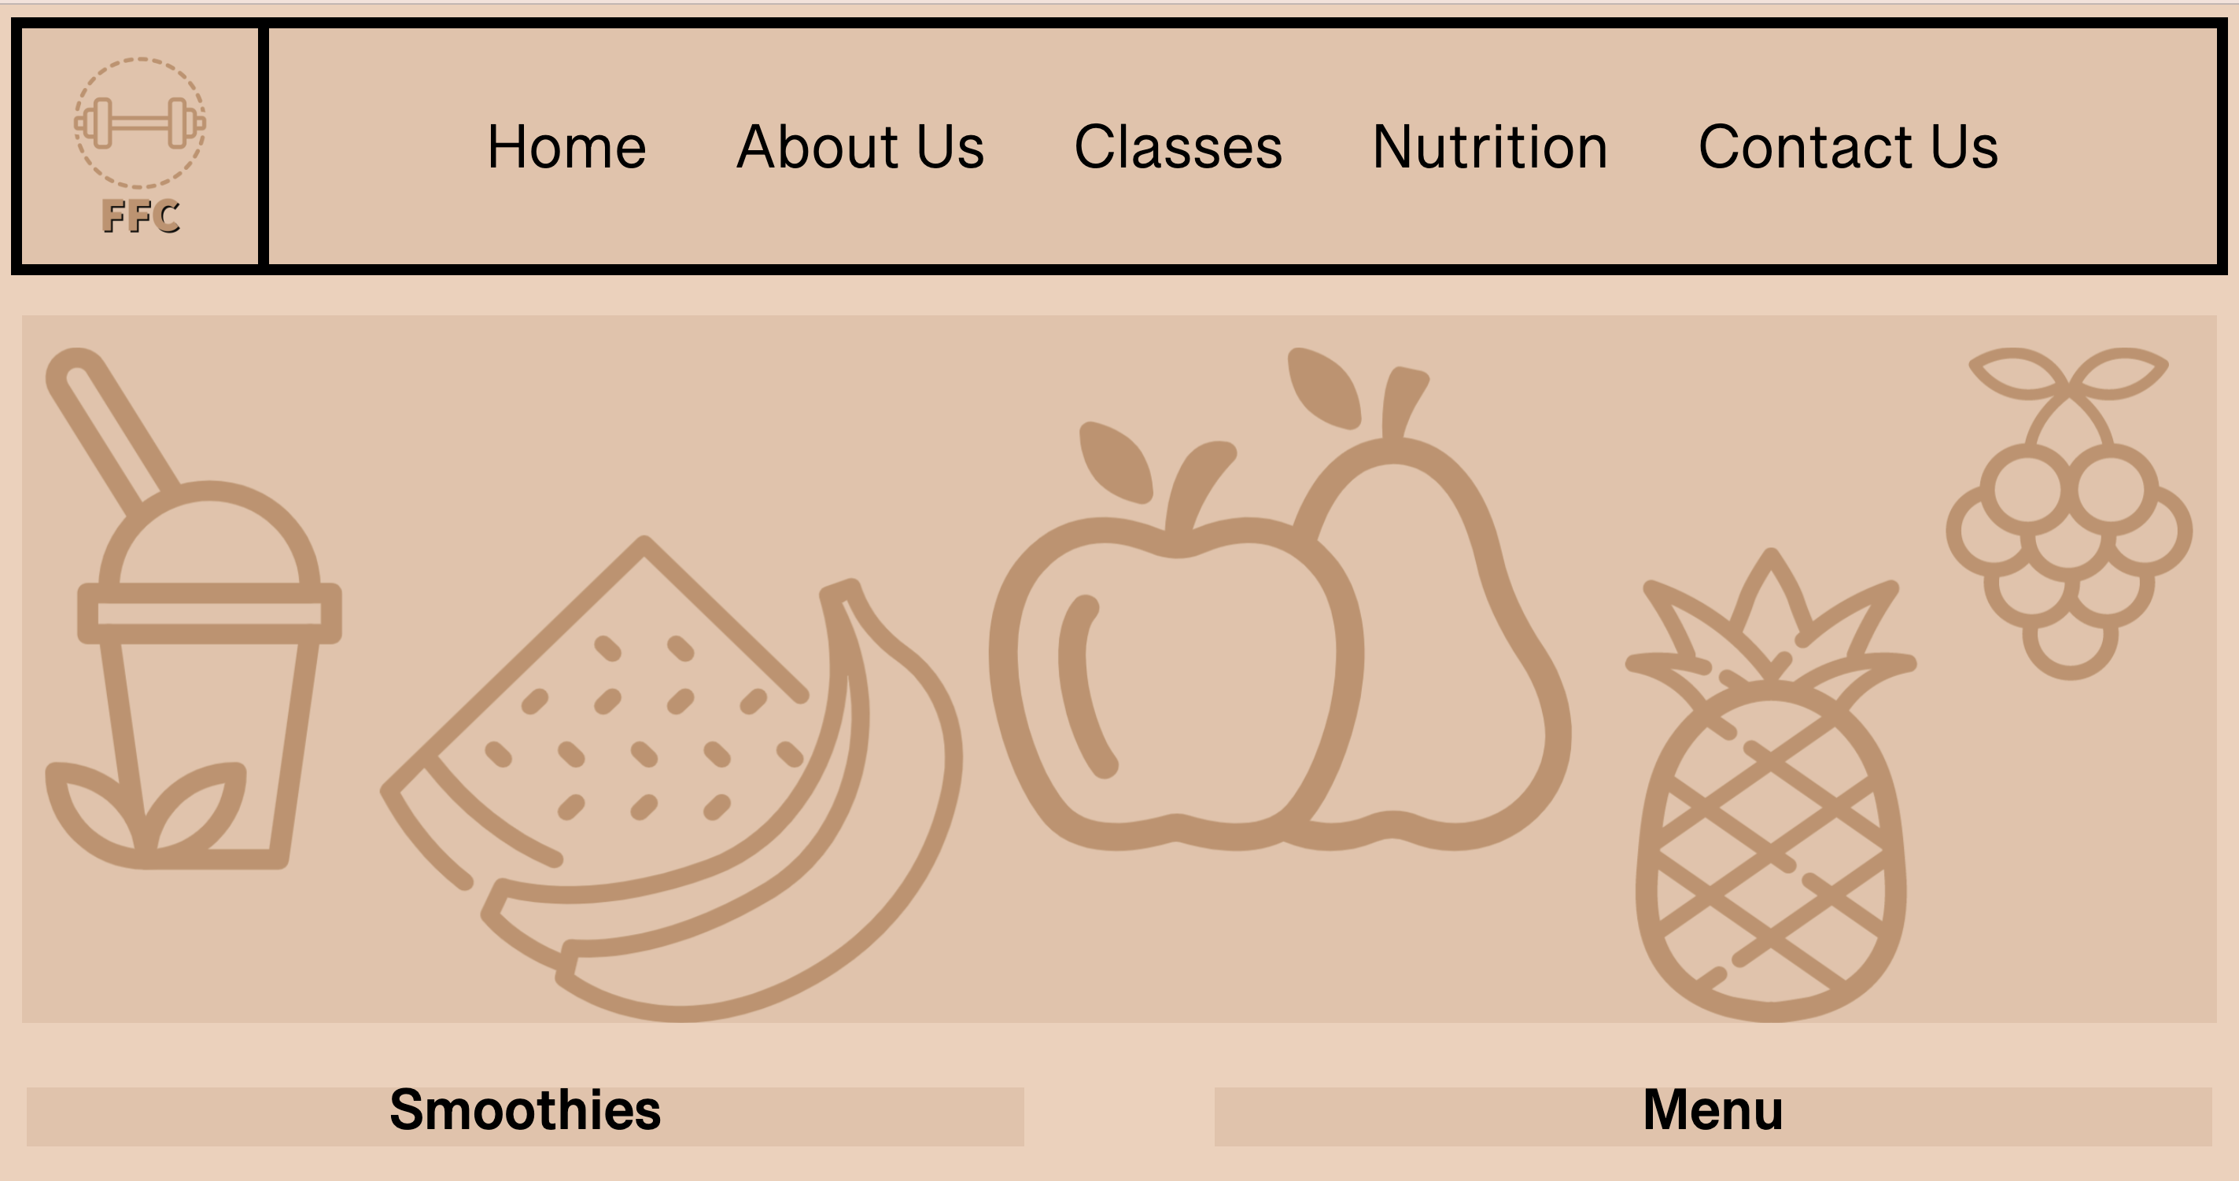

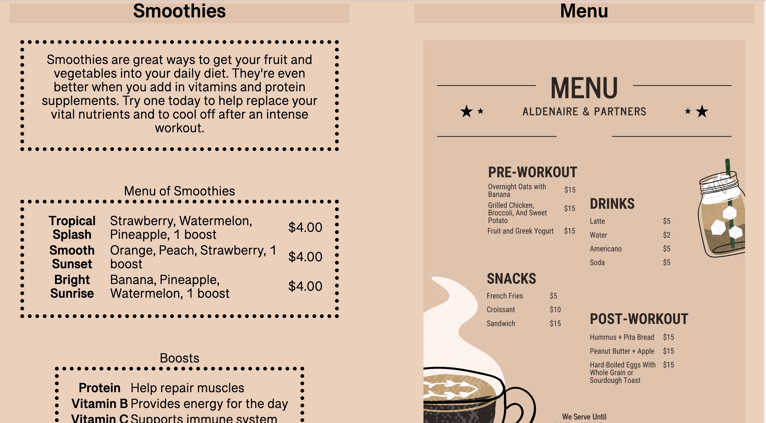

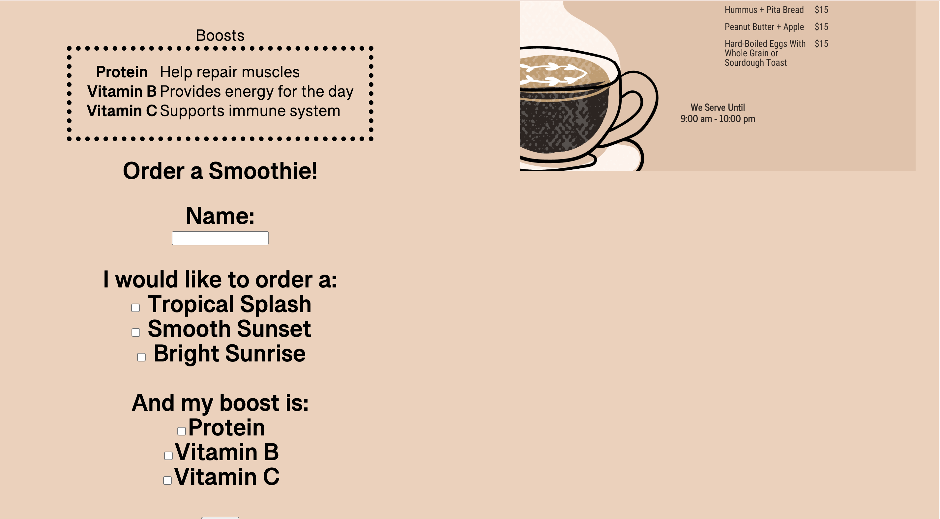



<DOCTYPE html>

<html lang="en">

<head>

<title> Falcon Fitness Center </title>

<meta charset="utf-8">

<link href="css/externalstylesheetFFC.css" rel="stylesheet">

<link href="https://fonts.googleapis.com/css2?family=Roboto&display=swap" rel="stylesheet">

</head>

<style>

nav{

width:99%;

background-color:#E6C3A9;

height:150px;

border:solid 7px black;

}

nav ol{

text-align:center;

top:100px;

}

nav ol li{

list-style:none;

display:inline-block;

justify-content: center;

margin-top:10px;

}

nav ol li a{

display:block;

text-decoration:none;

color:black;

font-size:40px;

font-weight:500;

padding:25px;

}

nav ol li a:hover{

background-color:#f0d0b9;

transition: all ease 1.5s;

}

.img{

float:left;

border:7px black solid;

}

</style>

<body>

<header>

<div class="img">

<a href="index.html"><img src="images/FFCLogoSecondary.png" alt="Falcon Fitness Center Logo" height="150px" width="150px"></a> <br>

</div>

<nav>

<ol>

<li><a href="index.html">Home</a></li>

<li><a href="about.html">About Us</a></li>

<li><a href="classes.html">Classes</a></li>

<li><a href="nutrition.html">Nutrition</a></li>

<li><a href="contact.html">Contact Us</a></li>

</ol>

</nav>

<main>

<br>

<div id="banner" class="desktop" style="margin:0px;">

<img src="images/FFCBanner.png" alt="banner of fruit" width="99%" height="450px" style="margin:0px; padding:0px;">

<section class="columcontainer" style="width:100%; margin:0 auto;">

<div class="colum1" style="width: 45%; float:left;margin:10px;">

<h1> Smoothies </h1>

<p> Smoothies are great ways to get your fruit and vegetables into your daily diet. They're even better when you add in vitamins and protein supplements. Try one today to help replace your vital nutrients and to cool off after an intense workout. </p>

<br>

<center><table>

<caption>Menu of Smoothies</caption>

<tr>

<th>Tropical Splash</th><td> Strawberry, Watermelon, Pineapple, 1 boost </td>

<td> $4.00 </td>

</tr>

<tr>

<th> Smooth Sunset</th> <td> Orange, Peach, Strawberry, 1 boost</td>

<td>$4.00</td>

</tr>

<tr>

<th>Bright Sunrise</th> <td> Banana, Pineapple, Watermelon, 1 boost </td>

<td> $4.00</td>

</tr>

</table>

<br>

<table>

<center>

<caption> Boosts </caption>

<tr>

<th> Protein </th> <td> Help repair muscles </td>

</tr>

<tr>

<th> Vitamin B </th><td> Provides energy for the day </td>

</tr>

<tr>

<th> Vitamin C</th> <td> Supports immune system </td>

</tr>

</center>

</table>

<h2> Order a Smoothie!<h2>

<form>

Name:<br>

<input type="text">

<br><br>

I would like to order a: <br>

<input type="checkbox" value="tropicalsplash">

Tropical Splash<br>

<input type="checkbox" value="smoothsunset">

Smooth Sunset<br>

<input type="checkbox" value="brightsunrise">

Bright Sunrise<br><br>

And my boost is:<br>

<input type="checkbox" value="protein">Protein<br>

<input type="checkbox" value="vitaminb">Vitamin B<br>

<input type="checkbox" value="vitaminc">Vitamin C<br><br>

<input type="submit" value="Submit">

</form>

</div>

<div class="colum2" style="width: 45%; float:right;margin:10px;">

<h1>Menu</h1>

<img src="images/Menu.png" height="800px" width="600px">

</main>

<center>

<footer style="clear:both;">

&copy; Copyright 2022. All Rights Reserved.

<a href="mailto:falconfitnesscenter515@gmail.com">

falconfitnesscenter515@gmail.com</a>

<a href="https://www.youtube.com/"><img src="images/youtube.png" alt="Youtube Logo" height="20" width="20"></a>

<a href="https://www.tiktok.com/"><img src="images/tiktok.png" alt="TikTok Logo" height="25" width="20"></a>

<a href="https://www.instagram.com/"><img src="images/instagram.png" alt="instagram Logo" height="20" width="20"></a>

<a href="https://www.facebook.com/"><img src="images/facebook.png" alt="FaceBook Logo" height="20" width="20"></a>

</footer>

</center>

</body>

</html>

Contact Us

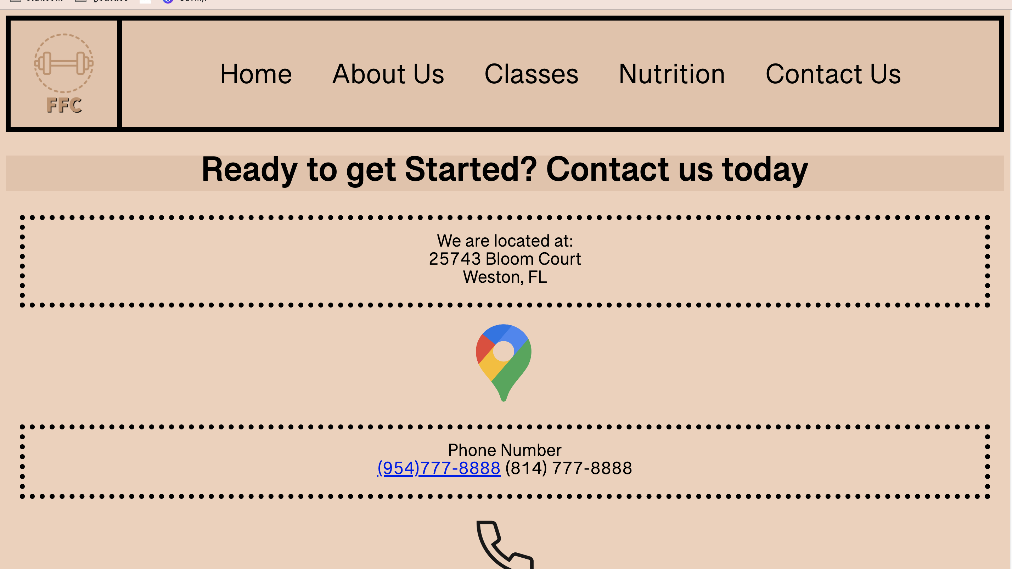

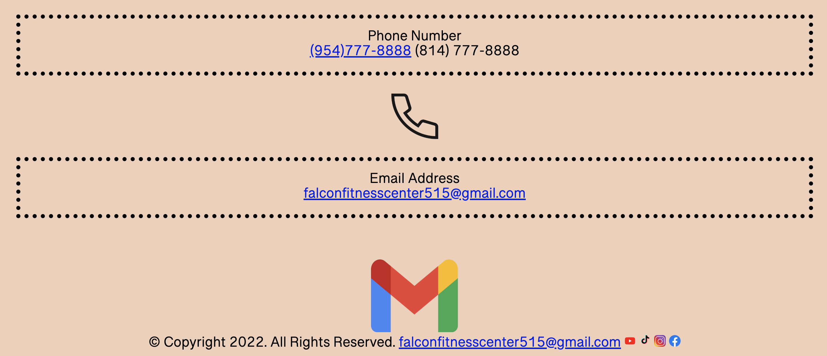

<DOCTYPE html>

<html lang="en">

<head>

<title> Falcon Fitness Center </title>

<meta charset="utf-8">

<link href="css/externalstylesheetFFC.css" rel="stylesheet">

<link href="https://fonts.googleapis.com/css2?family=Roboto&display=swap" rel="stylesheet">

</head>

<style>

nav{

width:99%;

background-color:#E6C3A9;

height:150px;

border:solid 7px black;

}

nav ol{

text-align:center;

top:100px;

}

nav ol li{

list-style:none;

display:inline-block;

justify-content: center;

margin-top:10px;

}

nav ol li a{

display:block;

text-decoration:none;

color:black;

font-size:40px;

font-weight:500;

padding:25px;

}

nav ol li a:hover{

background-color:#f0d0b9;

transition: all ease 1.5s;

}

.img{

float:left;

border:7px black solid;

}

</style>

<body>

<header>

<div class="img">

<a href="index.html"><img src="images/FFCLogoSecondary.png" alt="Falcon Fitness Center Logo" height="150px" width="150px"></a> <br>

</div>

<nav>

<ol>

<li><a href="index.html">Home</a></li>

<li><a href="about.html">About Us</a></li>

<li><a href="classes.html">Classes</a></li>

<li><a href="nutrition.html">Nutrition</a></li>

<li><a href="contact.html">Contact Us</a></li>

</ol>

</nav>

<main>

<h1> Ready to get Started? Contact us today </h1>

<p> We are located at: <br>

25743 Bloom Court<br>

Weston, FL </p>

<a href="https://www.google.com/maps"><img src="images/maps.png" alt="Google Maps Logo" height="125" width="100"></a>

<p> Phone Number <br>

<a class="mobile" href="tel: 9547778888">(954)777-8888</a> (814) 777-8888 </p>

<a href="https://www.youtube.com/watch?v=dQw4w9WgXcQ"> <img src="images/Phone.png" alt="Phone Logo" height="100" width="100"></a>

<p> Email Address <br>

<a href="mailto:forwardfitness515@gmail.com"> falconfitnesscenter515@gmail.com</a></p>

<br><br>

<a href="https://accounts.google.com/"> <img src="images/gmail.png" alt="gmail Logo" height="125" width="150"></a>

</main>

<footer>

<div class="center">

&copy; Copyright 2022. All Rights Reserved.

<a href="mailto:falconfitnesscenter515@gmail.com">

falconfitnesscenter515@gmail.com</a>

<a href="https://www.youtube.com/"><img src="images/youtube.png" alt="Youtube Logo" height="20" width="20"></a>

<a href="https://www.tiktok.com/"><img src="images/tiktok.png" alt="TikTok Logo" height="25" width="20"></a>

<a href="https://www.instagram.com/"><img src="images/instagram.png" alt="instagram Logo" height="20" width="20"></a>

<a href="https://www.facebook.com/"><img src="images/facebook.png" alt="FaceBook Logo" height="20" width="20"></a>

</footer>

</div>

</body>

</html>

ESS

body {

background-color:#f0d0b9 color:black;

font-size: 25px;

text-align:center;

}

h1 {

background-color:#E6C3A9;

color:black;

text-align:center;

}

p {

border: dotted 8px black;

padding:20px;

margin:20px;

border-width:10px;

border-radius:0px;

box-shadow:;

border-width:7px;

font-size:25px;

}

ul{

display:inline-block;

border:dotted 8px black;

padding:20px;

padding-bottom: ;

margin:20px;

border-width:7px;

border-radius:0px;

text-align:left;

}

.container1 {

margin-left:auto;

margin-right:auto;

}

.container2 {

display: flex;

}

table {

border: dotted 10px black;

padding:20px;

margin:20px;

border-width:10px;

border-radius:0px;

box-shadow:;

border-width:7px;

font-size:25px;

}